Level 3 -> Level 4

The goal of this level is to find the pass. to log into <http://natas4.natas.labs.overthewire.org>.

Username: natas4

After logging into level 3 we got a hint to get the password of next level. The hint is **“There is nothing on this page”**

Again, we will check the source code of the page. There is a hint for us which is commented in the source code **“No more information leaks!! Not even Google will find it this time”.**

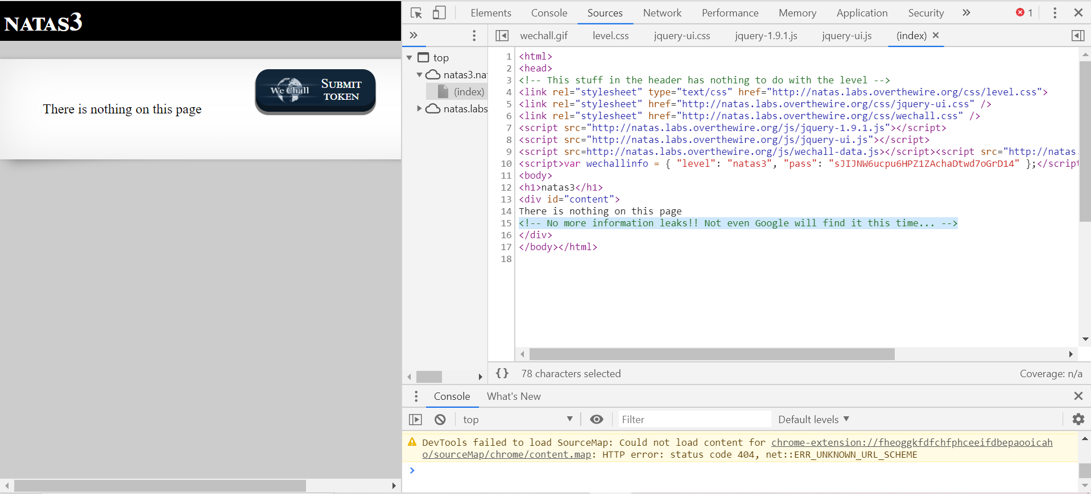

We will check for the robots.txt file. A robots.txt file lives at the root of the site. So, for site www.example.com, the robots.txt file lives at www.example.com/robots.txt. robots.txt is a plain text file that follows the [Robots Exclusion Standard](http://en.wikipedia.org/wiki/Robots_exclusion_standard#About_the_standard). A robots.txt file consists of one or more rules. Each rule blocks (or allows) access for a given crawler to a specified file path in that website. Navigate to <http://natas4.natas.labs.overthewire.org/robots.txt>. And here is a file named as **/s3cret/.** Navigate to <http://natas4.natas.labs.overthewire.org/s3cr3t>/



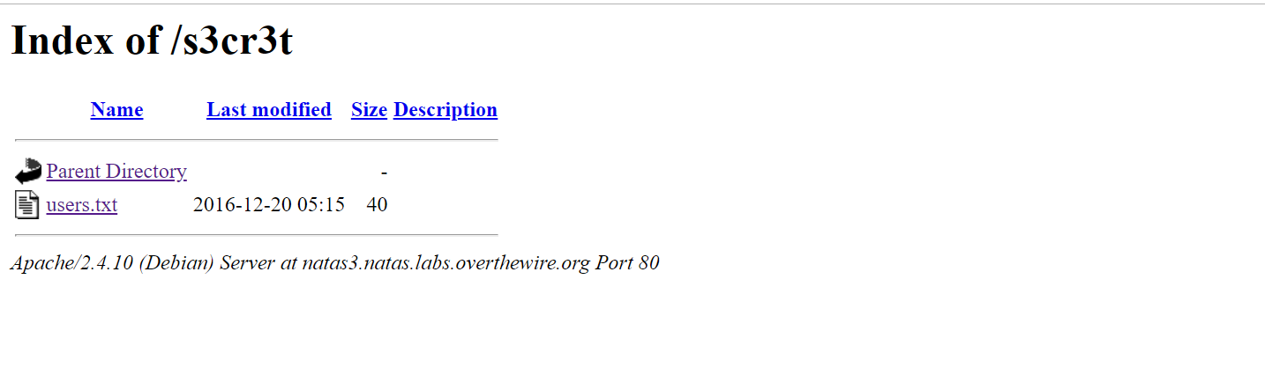

Open the users.txt file to get the password.

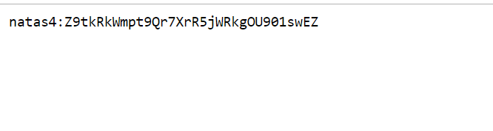

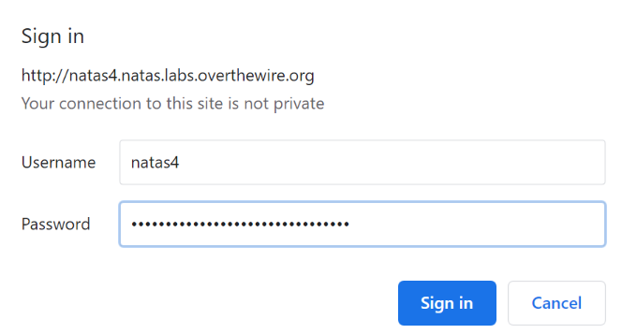

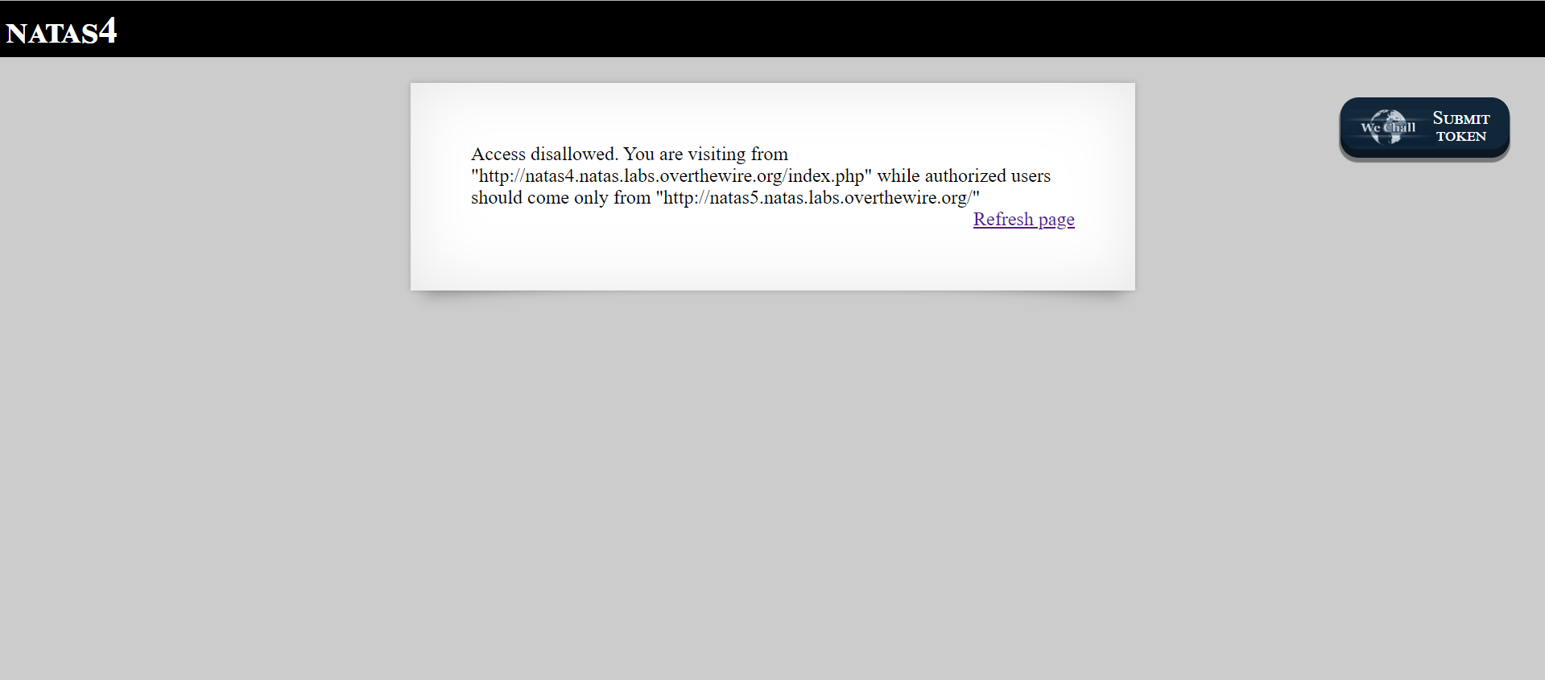

Successfully passed level 4.…